Beyond Baroque Literary Arts Center
http://www.beyondbaroque.org/calendar.html
681 N. Venice Blvd., Venice, CA 90291

5 December, Saturday - 8:00PM
AMY GERSTLER
AMY GERSTLER’s ten previous poetry collections include Bitter Angel, winner of the National Book Critics Circle Award, and Dearest Creature, a finalist for the Los Angeles Times Book Prize. She was also editor of The Best American Poetry (2010).
Join us as Amy reads from her recently published Penguin Poets volume, Scattered at Sea, which is a finalist for this year’s National Book Award. General Admission $10, Students & Seniors $6, Members Free.

6 December, Sunday - 5:00PM
FIRST SUNDAY OPEN READING
Our popular monthly open reading. Features this month, JENNIFER MACCIARELLA. Hosted by STEVE GOLDMAN. Sign ups begin at 4:45 PM. Five-minute limit. Free, but donations always appreciated.

6 December, Sunday - 7:30PM
WANDA COLEMAN MEMORIAL
Join the poetry community in paying homage to poet Wanda Coleman. Hosted by AUSTIN STRAUS. Free to all.

12 December, Saturday - 4:00PM
WRITING HEALING POETRY
CHANEL BRENNER, author of Vanilla Milk, MADELINE SHARPLES, author of Leaving the Hall Light On and ALEXIS RHONE FANCHER, author of State of Grace: The Joshua Elegies will discuss and read their poems about the loss of their sons.
Community Event: Suggested Donation $5-$10, no one turned away for lack of funds.

13 December, Sunday - 2:00PM
SOAP BOX OPEN READING
This is your home. Bring your words. The mic is yours. Sign ups begin at 1:45 PM. There is a five minute limit. Hosted by JESSICA
WILSON. FREE, but donations are always welcome.

Da Poetry Lounge
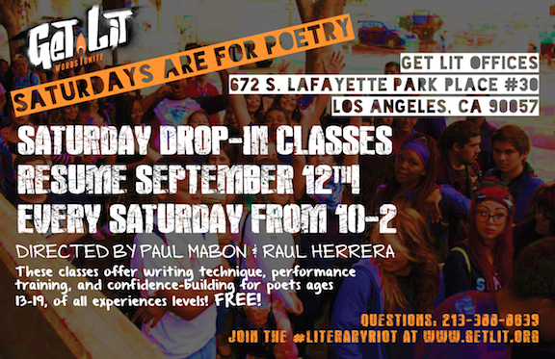
Greenway Court Theatre
544 N. Fairfax Blvd, Los Angeles, CA 90036
9 PM Tuesdays
$5 (cash only) on Open Mic Nights
$10 (cash only) on Slam Nights, the 3rd Tuesday of each month

