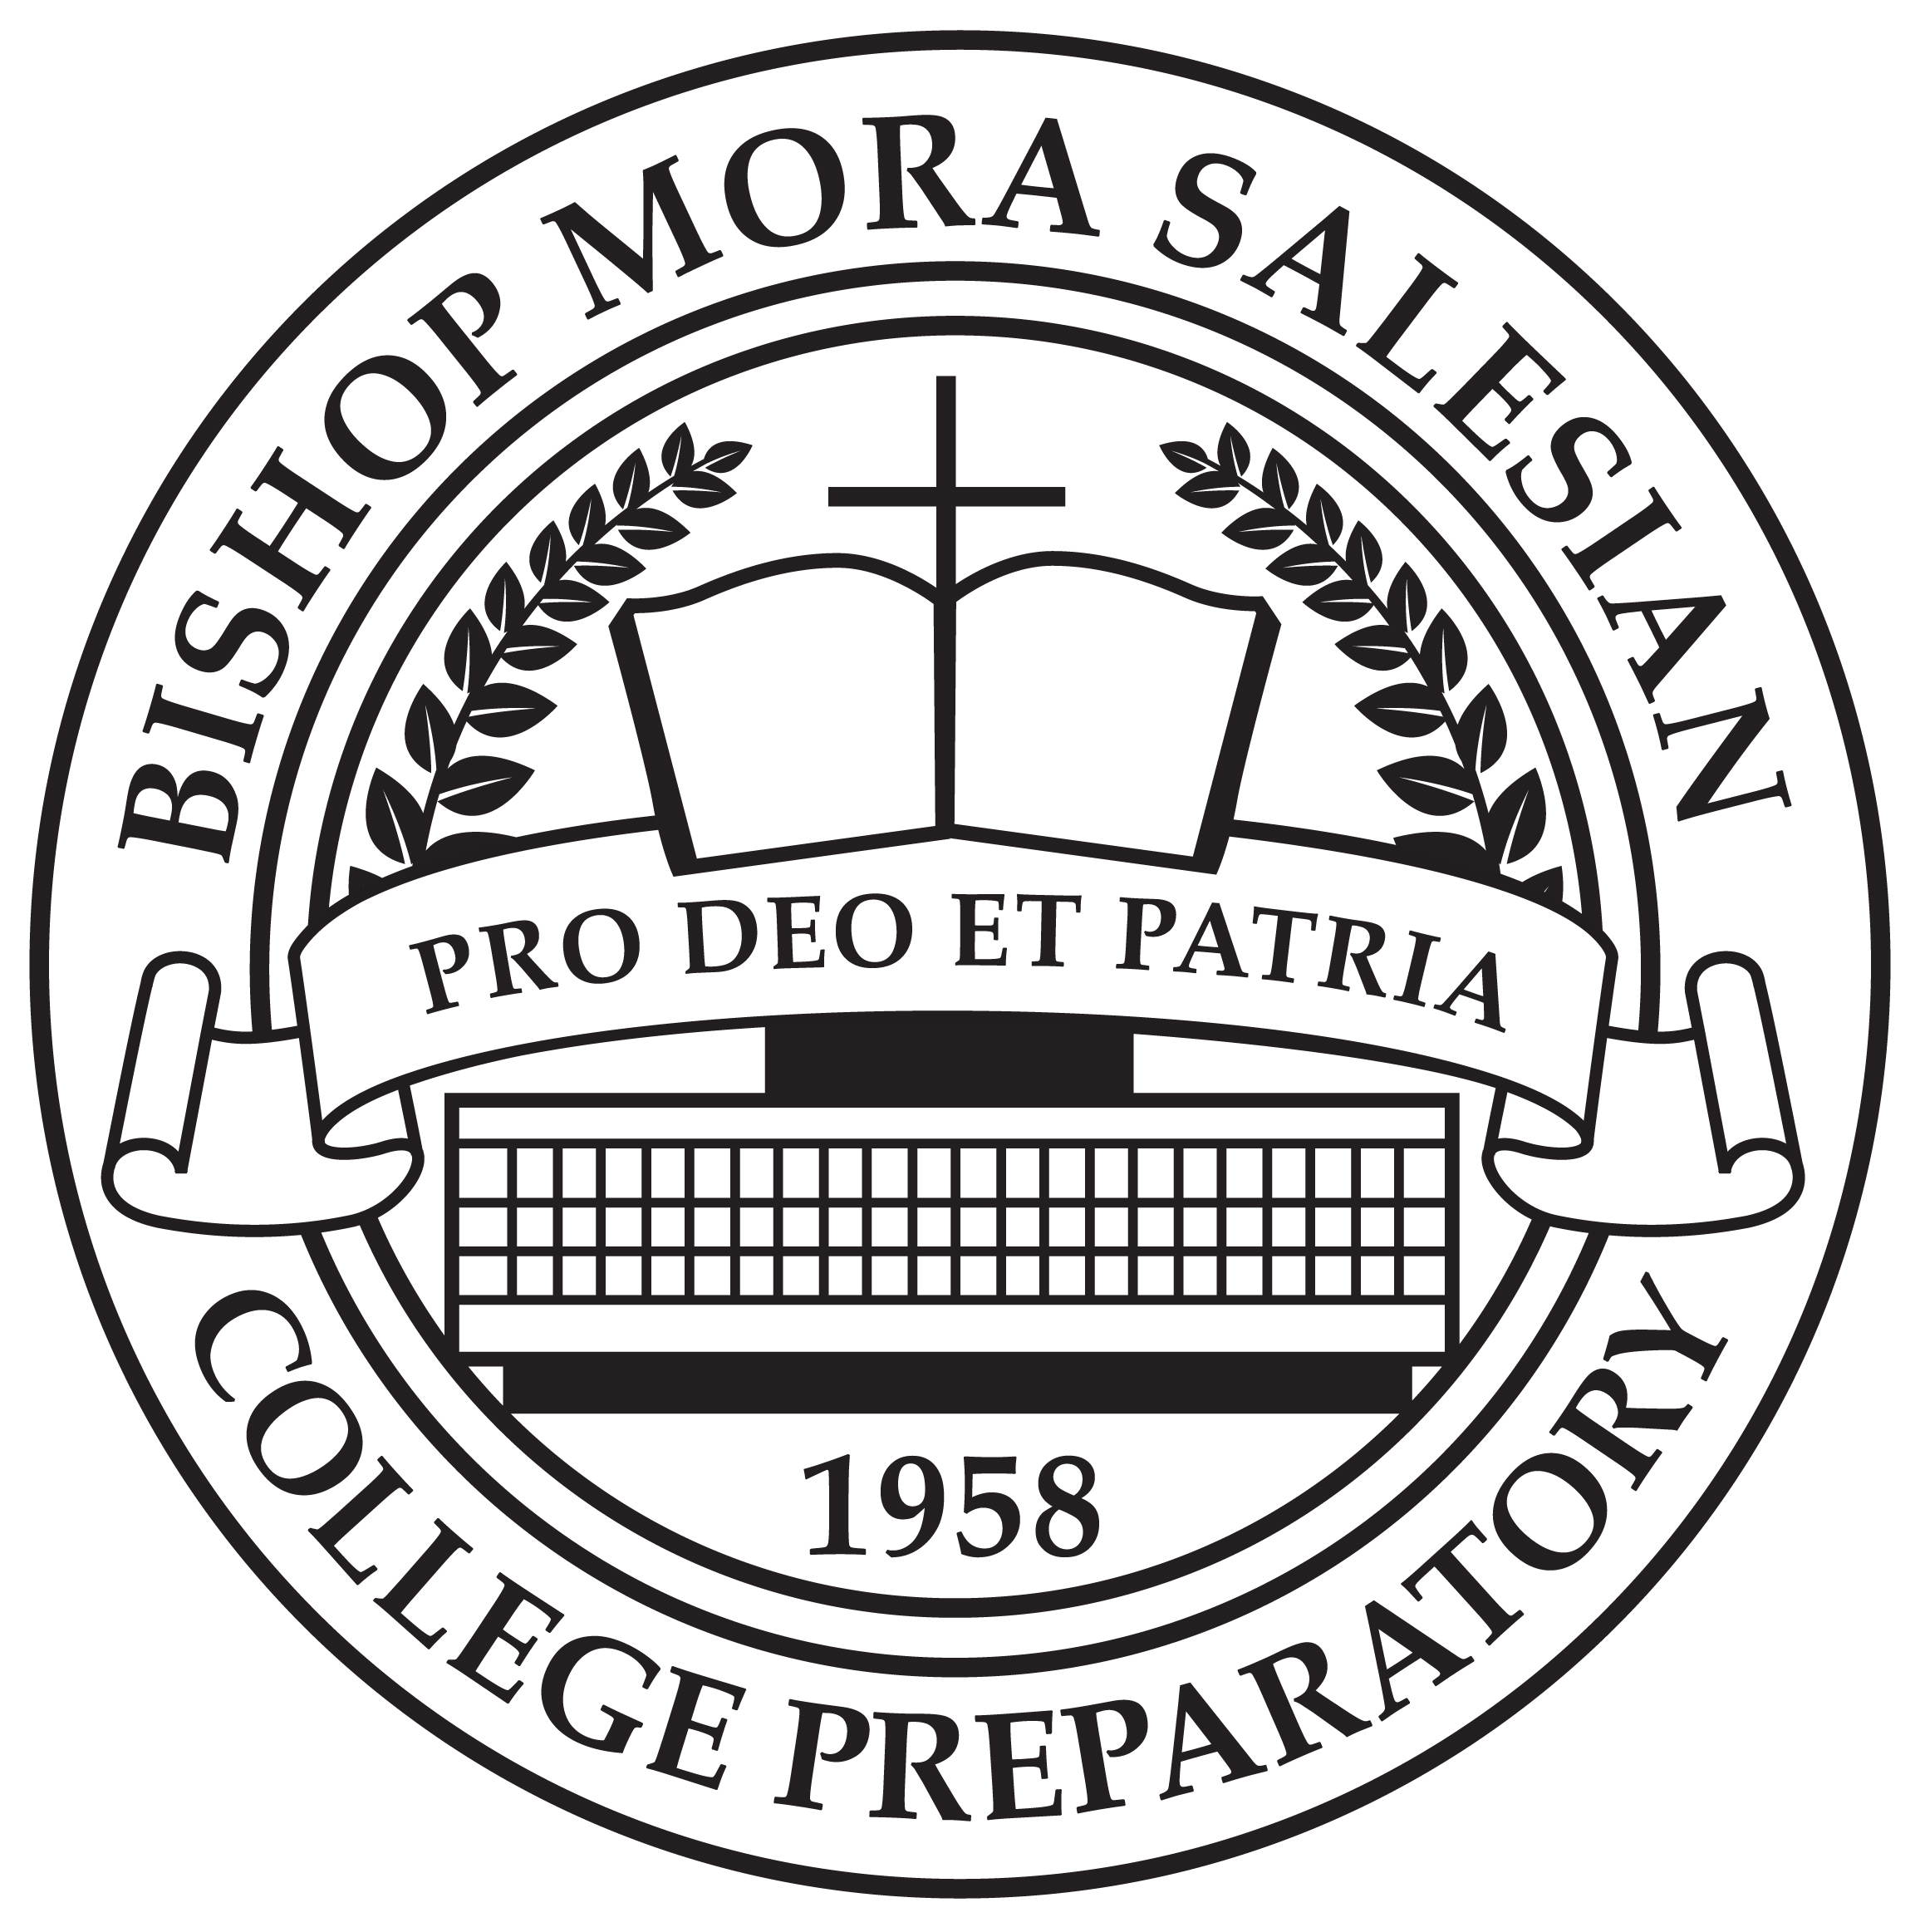

AP Literature and Composition
SYLLABUS
2015-2016
Instructor: | Ms. Goycoolea | Phone: | (323) 261-7124
E-Mail: | lgoycoolea@mustangsla.org | Class Location: | Room 315
Tutoring: Wednesday 2:30-3:15, Flex period, and by appointment

“Reading makes a full man, meditation a profound man, discourse a clear man.”
-Benjamin Franklin

Course Description
An AP English Literature and Composition course engages students in the careful reading and critical analysis of imaginative literature. Through the close reading of selected texts, students deepen their understanding of the ways writers use language to provide both meaning and pleasure for their readers. As they read, students consider a work’s structure, style and themes, as well as such smaller-scale elements as the use of figurative language, imagery, symbolism and tone. The course includes intensive study of representative works from various genres and periods, concentrating on works of recognized literary merit. The pieces chosen invite and reward rereading and do not, like ephemeral works in such popular genres as detective or romance fiction, yield all (or nearly all) of their pleasures of thought and feeling the first time through.
AP Central, College Board

Course Objectives
After completing this course, students will be able to…
- Analyze and critique literature and literary form through reading, writing and speaking
- Communicate in a powerful and civil manner
- Analyze a work’s structure, style, and themes as well as tone, diction, irony and other advanced literary techniques and concepts
- Think critically and argue in a persuasive manner using textual evidence
- Write to understand, explain, and evaluate through a variety of genres and reflect an understanding of purpose, voice, and audience
- Develop a wide-ranging vocabulary used appropriately and effectively
- Understand grammar usage and mechanics and apply this to writing and editing

Required Texts and Materials

Literature and Composition
How to Read Literature Like a Professor
1984
Hamlet (in textbook)
Oliver Twist (provided)
A Christmas Carol
Heart of Darkness (in textbook)
Rosencrantz and Guildenstern are Dead
Barron’s AP Literature and Composition
Lined paper and pen/pencil

Supplementary Texts and Materials
Additional texts will be determined and supplied by Ms. Goycoolea. Students will be responsible for attaining a copy of an independently read novel (a list of suitable novels will be provided by Ms. Goycoolea).

Grading Policy
Materials/Participation: Students must arrive prepared for class by completing homework/reading and bringing all required materials. Students must annotate texts and periodic materials/annotations checks will be completed. Students must participate in all class discussions (rubrics and guides will be given).
Assessment | % of Final Grade
Materials/Participation | 15%
Assignments | 15%
Quizzes/Timed Writes | 25%
Essays  Exams | 30%  15%
 | 100%
Assignments: Students will be required to complete various assignments both in class and as homework. These assignments are designed to prepare students for upcoming activities. Be sure to save all work, keep organized and avoid falling behind.
Quizzes/Timed Writes: Quizzes and timed writes will be assigned in class. Quizzes will cover both the reading and vocabulary. Save all timed writes.
Essays: Most units will conclude with a formal essay. The completion of an essay will include drafting, conferencing with the teacher, peer revision, and submission to turnitin.com.
Exams: The final and midterm exams will be in the form of multiple choice and essay questions styled after the AP Exam.

Grading Codes
In addition to points, the following codes may also be used in the online grade reporting system. Please also make sure to check the comment section of Aeries (view the full site mode on a smartphone).

CR | Credit | 100%
NP | Not Passing | 50%
INC | Incomplete | 50%
NA | Excused | No points count for or against

Additional Grading Policies

Late Work Policy: This is a college course and as such late work will not be accepted for any reason including absences. If you expect to be absent for a sport, doctor’s appointment, travel, etc., submit your work in advance or give your work to a trusted classmate to submit for you. Late work due to an unforeseen accident or major illness/injury may be accepted at Ms. Goycoolea’s discretion. A student needing more time to complete work should talk to Ms. Goycoolea for an extension prior to the due date. Students who do not complete an assignment will not be allowed to participate and will be sent to Academic Lock-Out.

Academic Lock-Out Policy: Work completed in Academic Lock-Out will receive a 40% grade reduction if turned in on the same day. Work will not be accepted after that day.

Extra Credit Policy: Extra credit opportunities will be assigned throughout the school year at Ms. Goycoolea’s discretion. Extra credit will not be given to any student trying to raise his grade immediately before the end of a grading period. Don’t even ask.

Academic Honesty: Academic honesty is of utmost importance in a college-level course. Any student found or attempting to cheat, copy another’s work, or plagiarize will be removed from AP Literature and Composition immediately and placed into the ERWC senior English class.

Attendance
Absent Work Policy: After returning from an absence, a student must check the ABSENT WORK binder. In this binder, the student will find any missed assignments/handouts and comments about the missed class. If the student has questions, he must ask another student before asking Ms. Goycoolea. Any work that was due on the date of the absence should have been submitted before the absence. Any work that was missed on the day of the absence will be due one class later.

Tardies: A student will be considered tardy if he is not sitting in his seat with his materials working on the warm-up by the bell rings. No negotiation or excuses.

Flex: There will be mandatory flex period class sessions throughout the year. A schedule will be given.

General Policies & Information

Ms. Goycoolea’s Expectations:

L Listen to whoever is speaking.

E Enter the classroom prepared. Bring all necessary materials and complete the homework/reading.

A Always try your best. There is no “can’t” in my classroom.

R Respect yourself and others.

N No excuses!

Restroom/Hall Passes: The restroom is to be used before or after class. Students will not be allowed out of class to use the restroom. In the case of desperate need, the student will owe Ms. Goycoolea a 15-minute detention at lunch or after school. Any student outside of the classroom will need a hall pass.

Technology: Ms. Goycoolea has set up a class assignment/homework blog and Twitter feed. Some of our class resources/readings will only be accessible through the blog. Students may also sign up for text message homework reminders by texting the code below to the phone number below.

Twitter: @MsGoycoolea

Website: http://msgoycoolea.weebly.com/

Text Message Reminders: text “@msgaplit16” to 81010

Occasionally, Ms. Goycoolea will ask students to use smartphones in class to enhance lessons. A smartphone is not required to participate, however. Cellphone use will be revoked if abused.

Schedule
Units of Study | Major Assessments/Projects
Introduction to the Literary Canon and AP  In this unit, students will investigate what “qualifies” a novel to be included in the AP literary canon. We will investigate the term “literary merit” and how it applies to the AP course. This unit will also explore the format and content of the AP course and exam. | - Summer Reading Assignment  - Timed Writes
Bootcamp  This unit will help students review key literary elements and essay mechanics. With a special focus on literary devices including tone, theme, syntax, and diction, students will begin to explore the essential questions regarding the universal human condition. | - Timed Writes  - Bootcamp exam
AP: Always Poetry  The various poems selected in this unit will introduce students to the literary concepts of allusion and extended metaphor. With special focus on poetic form, we will explore both classical and contemporary poetry. Using these concepts, students will write poetry. | - Sonnet Writing  - Timed Writes
Dystopia and Governmental Power  In this unit students will read 1984 and discuss the power of government versus the power of citizens. This postmodern novel will give students an opportunity to discuss multiple themes and Orwell’s warnings for society. (This unit is subject to change.) | - Timed Writes  - Formal Process Essay
Independent Novel Project Due and Standardized Testing
The Personal Essay  In this unit, students will write a personal, reflective essay that will potentially be used as a college application essay. | - Personal Statement
Social Responsibility and Criticism  Students will study Charles Dickens’ classic work, Oliver Twist with a focus on social criticism. We will utilize excerpts from A Christmas Carol to more fully understand Dickens’ unique voice and his critique of Victorian society. | - Timed Writes  - Formal Process Essay
Midterm Exam/Practice AP Exam
Shakespeare  In this unit, students will explore drama to investigate the language and form of Shakespeare’s plays, the role of comedy in tragedy, and the complexity of Shakespearean characters through one of the Bard’s most famous plays, Hamlet. | - Formal Process Essay  - Timed Writes
Existentialism and the Meaning of Life  In this unit, students will explore the complex theory of existentialism through the genre of Theatre of the Absurd. Stoppard’s playful writing in Rosencrantz and Guildenstern are Dead expands the themes and characters from Hamlet into a more modern context of philosophical thought. | - Timed Writes  - Mini-Essay
Independent Novel Project (Optional)
Savagery vs. Civility  Students will look at the work of Joseph Conrad and his novella, Heart of Darkness. We will discuss the use of frame narrative and the theme of savagery vs civility. | - Timed Writes
AP Exam Review
AP Exam: Wednesday May 4th at 8:00am

Book Sale Information
While we are studying texts outside of the textbook, students are responsible for purchasing and bringing the novel to class. Material checks will be completed and affect a student’s Materials/Participation grade. Students will not be permitted to access online or digital versions of the texts. Here is the breakdown of additional text availability and pricing:

How to Read Literature Like a Professor: $10.52
1984: $6.00
A Christmas Carol: $2.50
Rosencrantz and Guildenstern are Dead: $10.47

Total: $32.15 (including tax) Total (minus How to Read…): $20.70 (including tax)

Total per student due to Ms. Goycoolea. Ms. Goycoolea would HIGHLY recommend that students order the texts through her in order to purchase the same versions of the texts (and to access her free shipping on Amazon).

Parent
I have read and reviewed this syllabus with my son. I understand that small changes will be made at the discretion of the instructor. I understand the policies and procedures in this syllabus and agree to hold my son to the standards established by this instructor and Salesian High School. I understand that any instance of academic dishonesty will result in my son’s immediate removal from the class.

Parent Name: _________________________________________________________________________
Parent Signature: ______________________________________________________________________
Parent Email*: _________________________________________________________________________

Please provide an email so as to receive the most updated information about your son’s performance and behavior in class!

Student
I have read and reviewed this syllabus. I understand the policies and procedures in this syllabus and understand that I am expected to be respectful, attentive, and prepared for every class meeting.

Student Name: ________________________________________________________________________
Student Signature: _____________________________________________________________________

